**Name-Shivam Saxena**

**Sap-ID-500062332**

**Roll No.-r100217070**

**Batch-2**

**Project Steps**

**Step-1:**Add sphere using hot key shift+A, and then duplicate the sphere to make more sphere as per the requirement.

**Step-2:** Go to edit mode and move the sphere along y-axis. Moving sphere in edit move because it fix the origin which is useful during animation.

**Step-3:** Scale the sphere to different sizes with respect to bigger one using hot key S.

**Step-4:** now add a circle to make the ring of the bigger sphere and another one for the path of the planet.

**Step-5**: extrude the circle using hot key E and then scale the the circle to make it wider.

**Step-6:** select another circle to scale it to median radius by using hot key ctrl+A.

**Step-7:** Now as our modelling of planets done we are move towards the shading part.

**Step-8:** For shading I use image texture to give different colors to different sphere.

**Step-9:** make circle and sphere parent object by using hot key ctrl+p. we make this because we want to show the smaller sphere and path rotate together around the bigger one sphere.

**Step-10:** Insert key frames to make the rotation of sphere and circle around the bigger sphere demonstrate the planetary motion.

**Step-11:** At then end render the whole file using evee rendering engine to make the animation smooth.

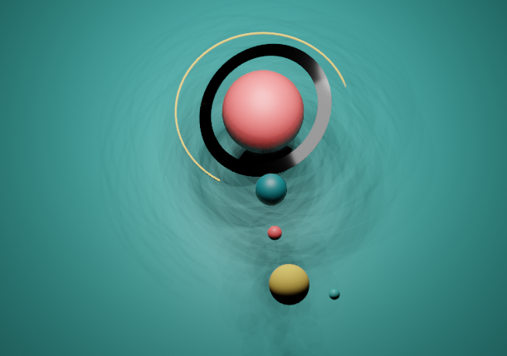

Drive Link: <https://drive.google.com/drive/folders/1uh55wFB0Vz3bGRAX4hkjHmCVnNvmlfhf?usp=sharing>

Blender File: